# Objectives:

To design a 16-bit processor that can perform basic arithmetic’s and a co-processor that perform operations on floating points.

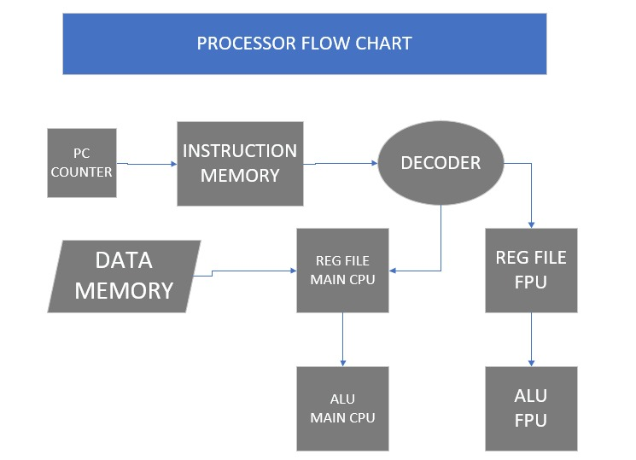

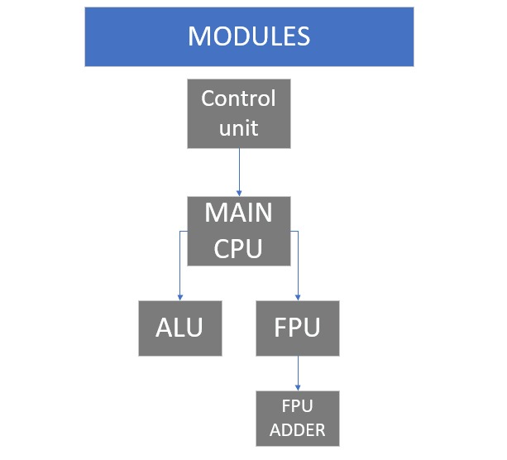

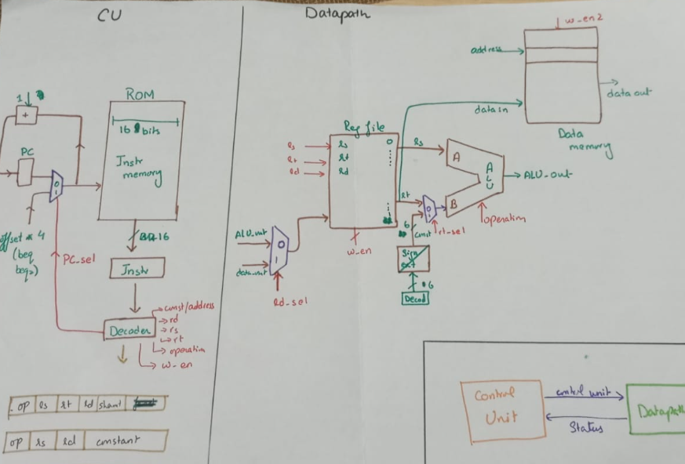

# 

# Working:

The instruction is working on clock. The decoder will divide the instructions into different components. The operations will be performed based on the opcodes. Some designated opcodes will ensure operations in Main processor using it’s ALU while other opcodes will lead to operations in the Co-processor.

# Conclusion:

A main processor was built to perform basic arithmetic’s and separate processor for operation on floating points to save the main processor from complexities, to save time and give accurate results.